
Woodstock Tribute Band – Stage plan

Frans Ceelen +31 6 30410231 fransceelen98@gmail.com

Sander v/d Berk +31 6 25535681 s.vandenberk@me.com
www.woodstock-tribute.nl

STAGE RIDER
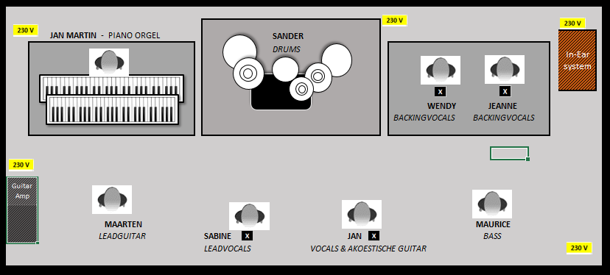

- In-Ear system (XLR > FOH) will be placed on the right or left at the back of stage
- Power supply for: keyboards - bass/acoustic guitar - in-ear system & e-drums - guitar-amp.
- - microphone Vocals (3x), Sabine (leadvocals) brings her own wireless microphone.
- 1x riser for drums.
- If possible 1x riser for backing vocals and 1x riser for keyboards.

Line Up
Sander | Electronic Drums
Maurice | Bass
Maarten | Guitar (Kemper amp stereo)
Jan Martin | Orgel, Piano
Sabine | Lead vocals (own wireless microphone)
Jan | Lead vocals, Guitar (acoustic)
Wendy | Background vocals
Jeanne | Background vocals

Woodstock Tribute Band – Stage plan

Frans Ceelen +31 6 30410231 fransceelen98@gmail.com

Sander v/d Berk +31 6 25535681 s.vandenberk@me.com
www.woodstock-tribute.nl

Woodstock Tribute Band uses its own monitor table and its own In-ear system with splitter.
All signals except drums go through the splitter, drums go straight to FOH and is sent back to the monitor table as a complete drum mix (signal 1 multi cable).
Woodstock Tribute Band supplies 2 XLR multi cables of 3 meters long, on the right or left at the back of the stage for inserting the XLR plugs 1 to 13 for channel 11 to 22 and the return drum-mix, and plug 14 for Talk-Back FOH - see below list.
The in-ear drum mix must be supplied from the FOH via signal 1 from stage splitter to the monitor table.
Woodstock Tribute Band supplies 2 stage blocks for the inputs and outputs of the band on stage.
CHANNEL LIST
CHANNEL (FOH) |  | NAME | IN- EARS | SPLITTER
1 | Kick | Sander | IE Wired | 1
2 | Snare top |  |  | RETURN
3 | Snare bottom |  |  | DRUM SIGNAL
4 | H.H.
5 | Tom 1
6 | Tom 2
7 | Floor 1
8 | Floor 2
9 | O.H. L.
10 | O.H. R
11 | Bass | Maurice | Sennheiser EW300IEM | 2
12 | Acoustic Guitar | Jan |  | 3
13 | Guitar L | Maarten | Sennheiser EW300IEM | 4
14 | Guitar R | Maarten | Sennheiser EW300IEM | 5
15 | Orgel L | Jan Martin | IE Wired | 6
16 | Orgel R | Jan Martin | IE Wired | 7
17 | Piano L | Jan Martin | IE Wired | 8
18 | Piano R | Jan Martin | IE Wired | 9
19 | Lead vocals | Sabine | Shure PSM900 | 10
20 | Lead vocals | Jan | Sennheiser EW300IEM | 11
21 | Backing vocals | Wendy | LD Systems MEI1000G2T | 12
22 | Backing vocals | Jeanne | LD Systems MEI1000G2T | 13
 |  |  |  | 14
 |  |  |  | 15
 | Talk-Back FOH |  |  | 16

Woodstock Tribute Band – Stage plan

Frans Ceelen +31 6 30410231 fransceelen98@gmail.com

Sander v/d Berk +31 6 25535681 s.vandenberk@me.com
www.woodstock-tribute.nl

MULTI CABLE In-ear rack <=> FOH
Signal No | Description | Direction
1 | Drum mix | From FOH aux
2 | Bass | to FOH
3 | Acoustic Gitaar | to FOH
4 | Gitaar L | to FOH
5 | Gitaar R | to FOH
6 | Orgel L | to FOH
7 | Orgel R | to FOH
8 | Piano L | to FOH
9 | Piano R | to FOH
10 | Lead vocals Sabine | to FOH
11 | Lead vocals Jan | to FOH
12 | Backing vocals Wendy | to FOH
13 | Backing vocals Jeanne | to FOH
14
15
16 | Talk-Back FOH | From FOH

